Experiment No. 4
Title : Design and develop custom Application (Mini Project) using Salesforce Cloud.
Name : - Shravani Mallinath Talwar
Roll No. : - CO3110
Class : - TE Computer
Subject : - Cloud Computing

*********************************************************************
Step 1 : Create new org:
https://developer.salesforce.com/signup
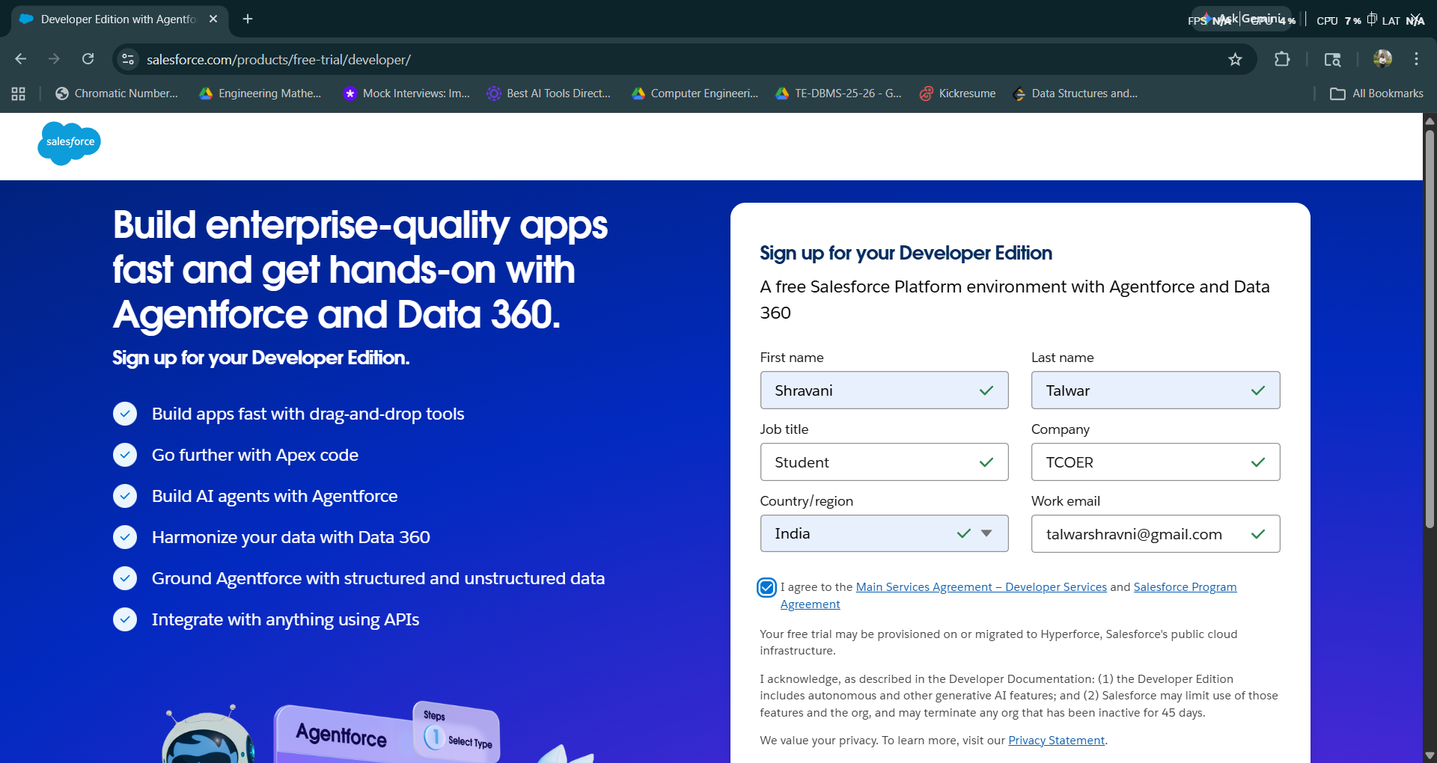
Step 2 : After signup, loging using following URL https://login.salesforce.com/
Step 3 : Login Page (Enter your credential to login)
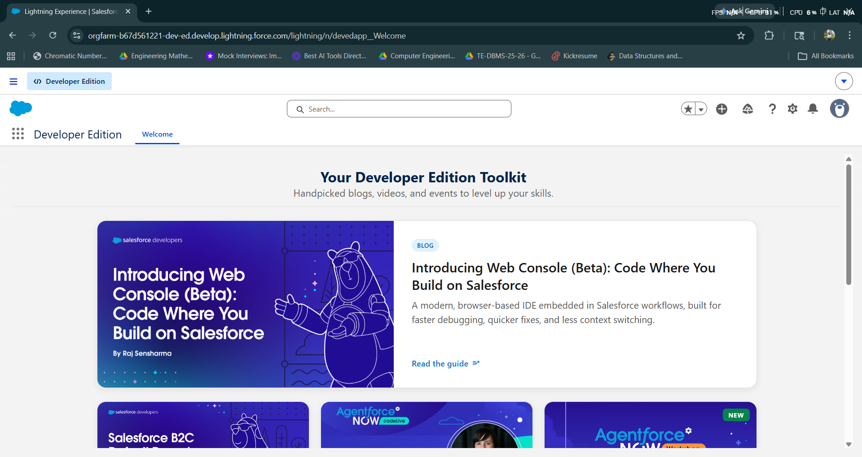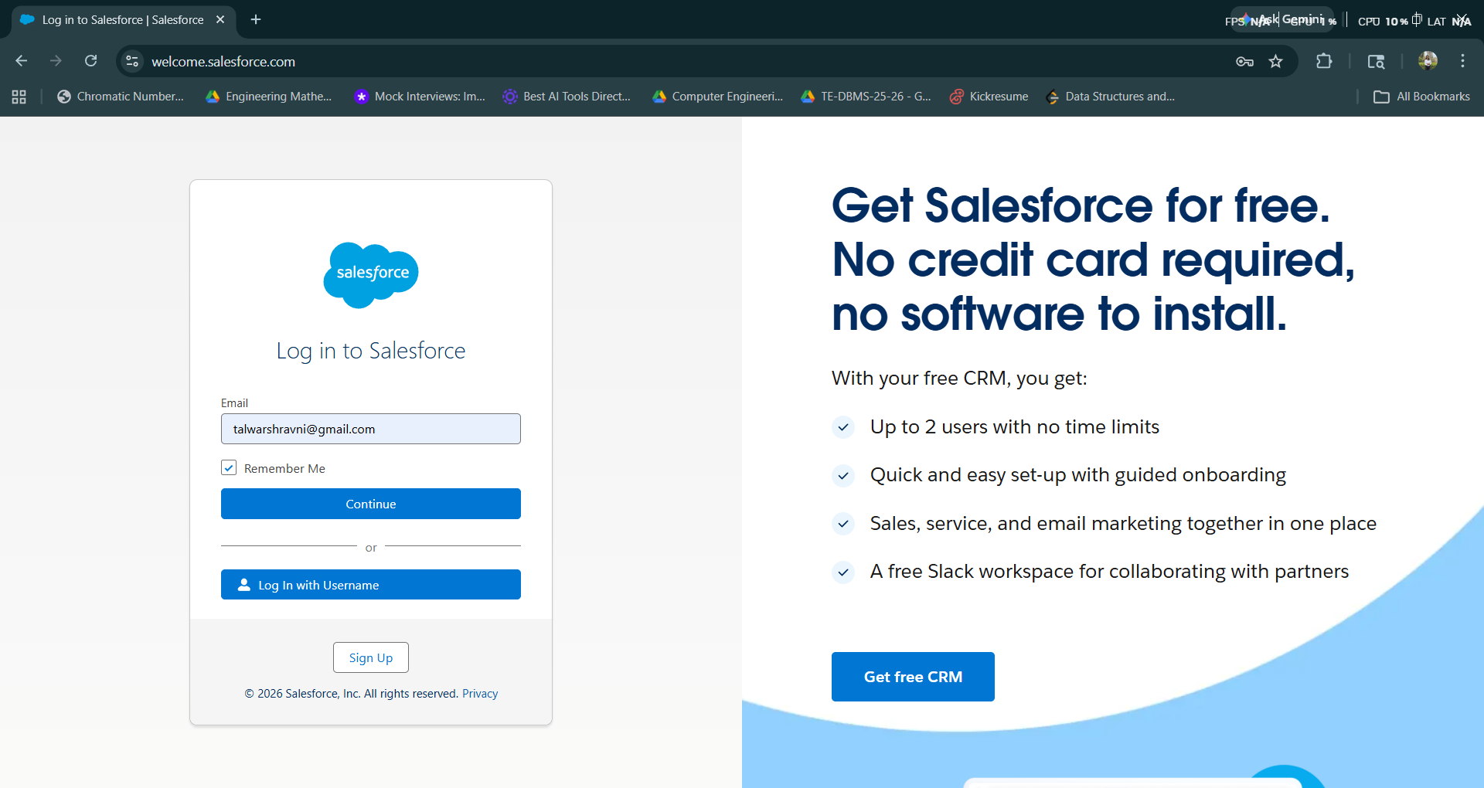
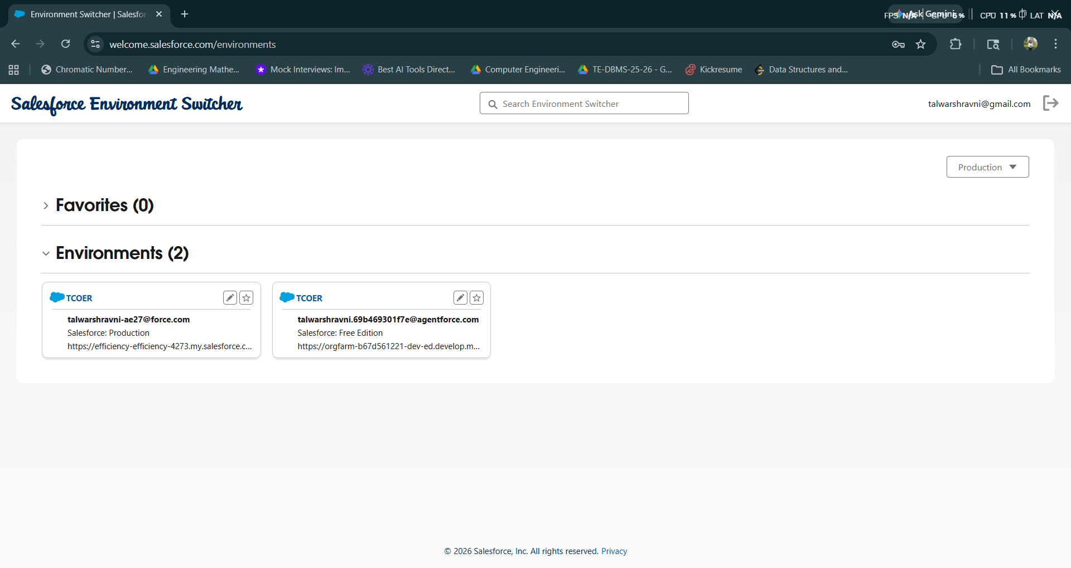
Step 3a : Open salesforce in Lightning Experience
Switch to Lightning Experience if not already enabled.
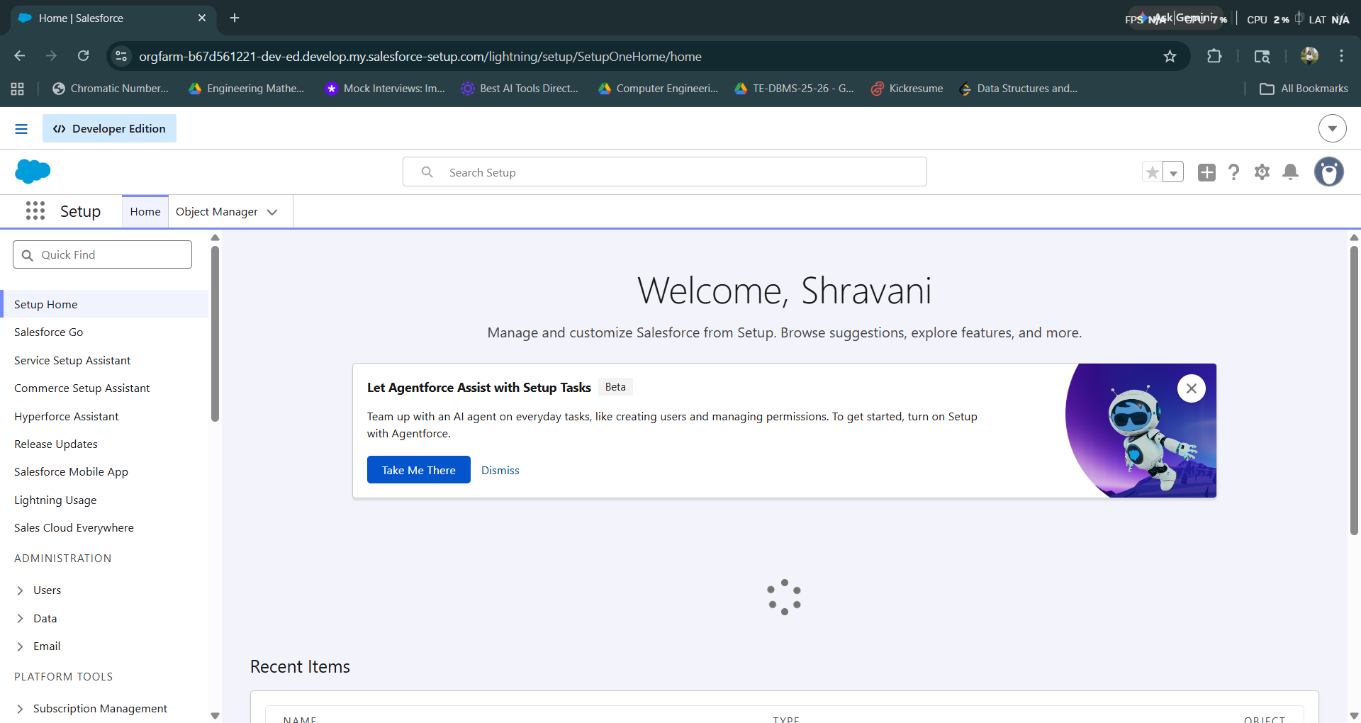
Step 3b : Click on Object Manager
Navigate to Setup → Object Manager
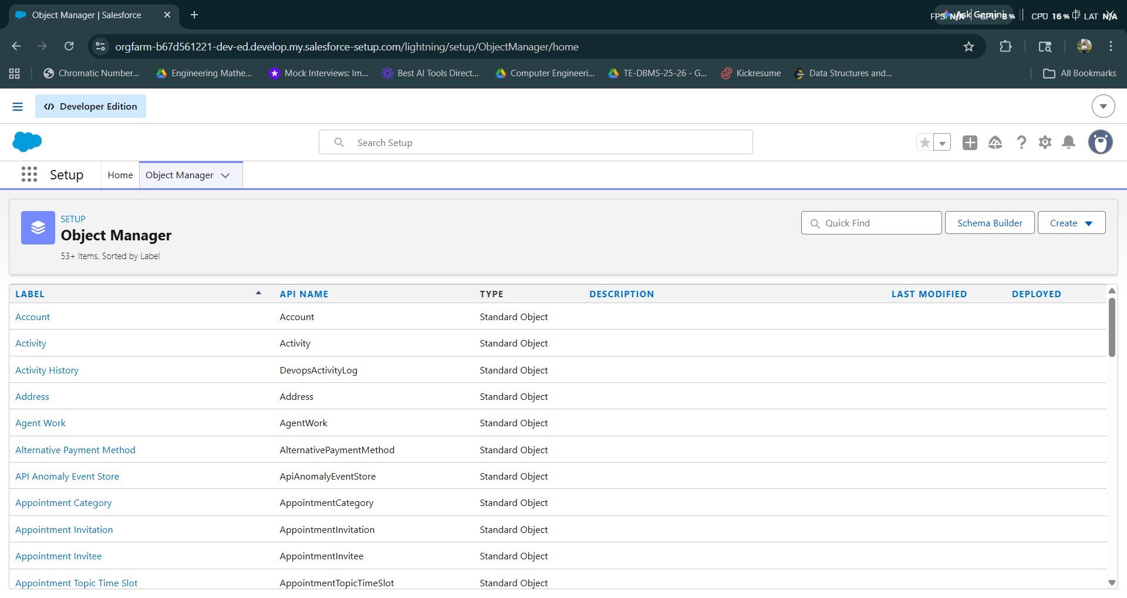
Step 3c : Click on Create → Custom Object
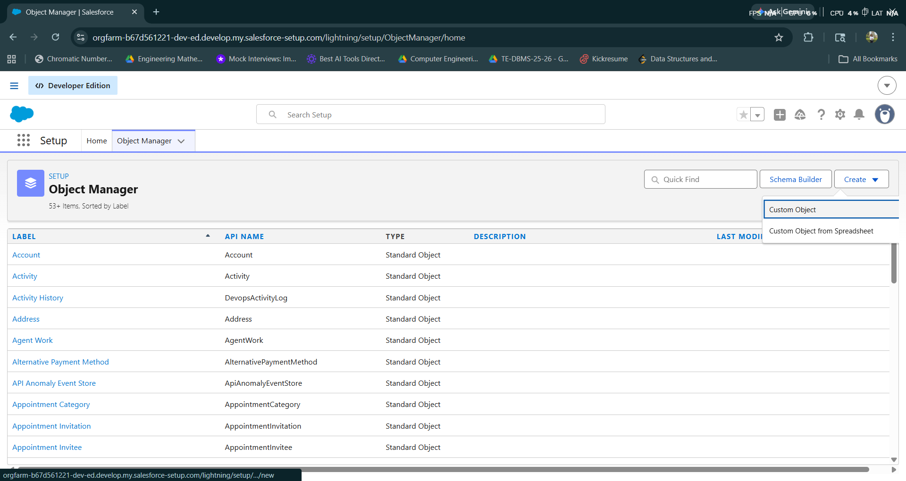
Step 3d : Create new Custom objects:
1. Candidate
2. Job Opening
3. Application
4. Interview
5. Recruiter
6. Offer
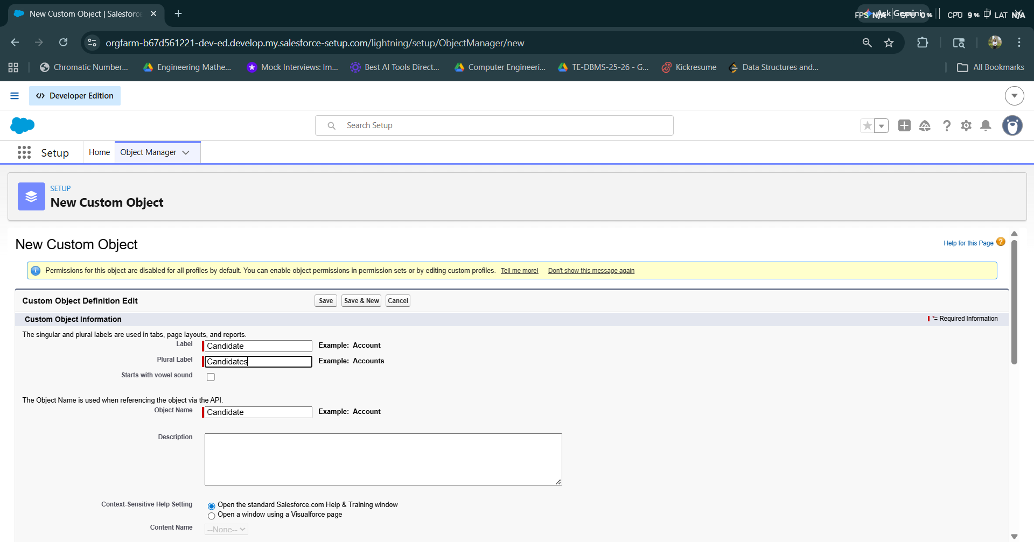

Step 3e : Go to Field and Relationships field of these objects and create new Relational fields
- For Candidate:
- Email (Email)
- Phone (Phone)
- Experience (Number)
- Skills (Long Text Area)
- For Job Opening:
- Job Title (Text)
- Department (Picklist: IT, HR, Sales)
- Location (Text)
- Salary Range (Text)
- Status (Picklist: Open, Closed)
- For Application:
- Candidate (Lookup → Candidate)
- Job Opening (Lookup → Job Opening)
- Application Date (Date)
- Status (Picklist: Applied, Screening, Interview, Selected, Rejected)

- For Interview:
- Application (Lookup → Application)
- Interview Date (Date/Time)
- Interview Type (Picklist: HR, Technical)
- Feedback (Long Text Area)
- Result (Picklist: Pass, Fail)
- For Recruiter:
- Email (Email)
- Department (Text)
- For Offer:
- Application (Lookup → Application)
- Offered Salary (Currency)
- Joining Date (Date)
- Offer Status (Picklist: Sent, Accepted, Rejected)
Create Relationships:
- Candidate → Application (One-to-Many)
- Job Opening → Application (One-to-Many)
- Application → Interview (One-to-Many)
- Application → Offer (One-to-One)

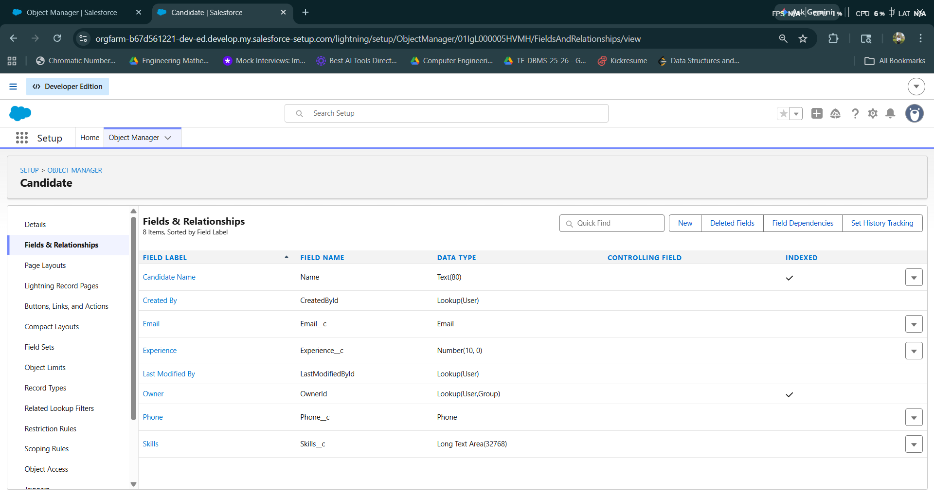
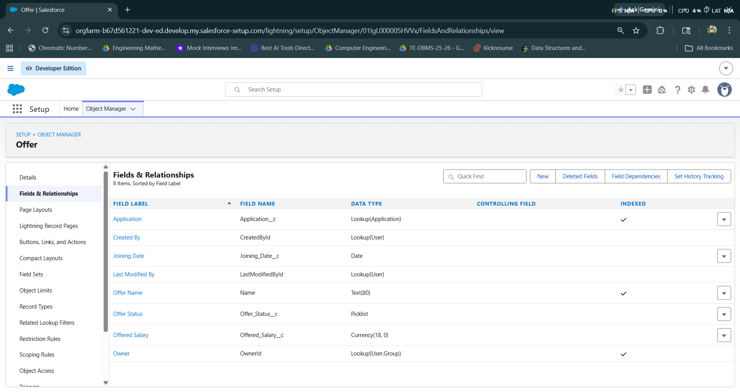
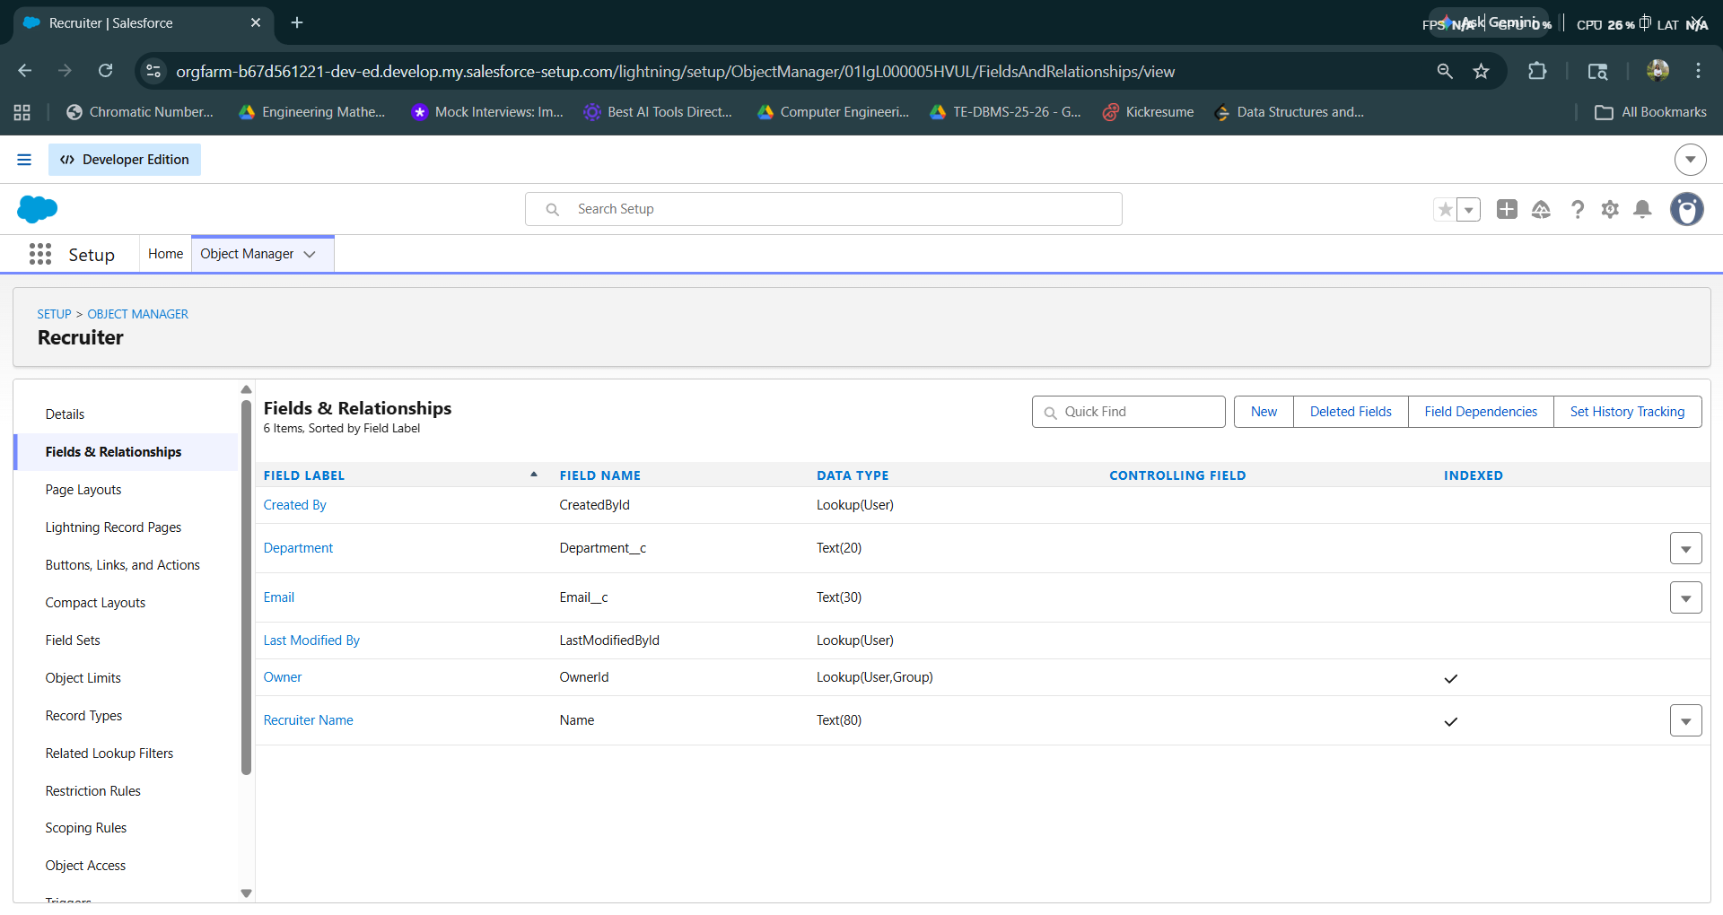
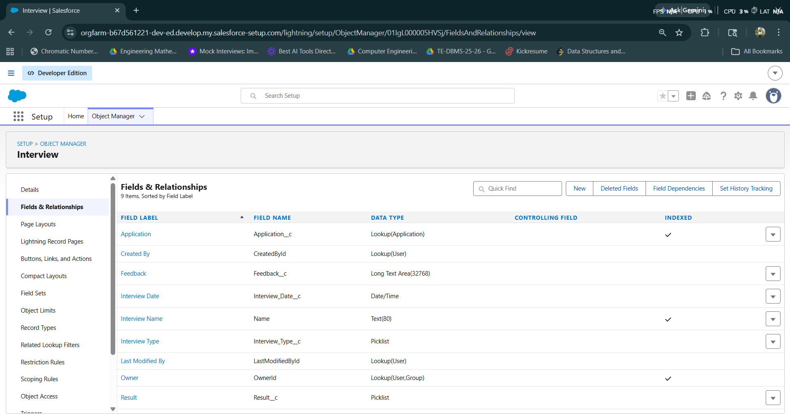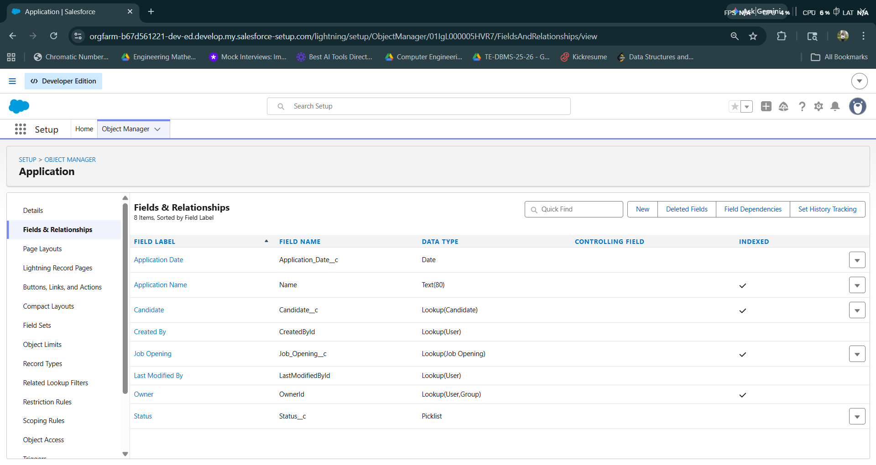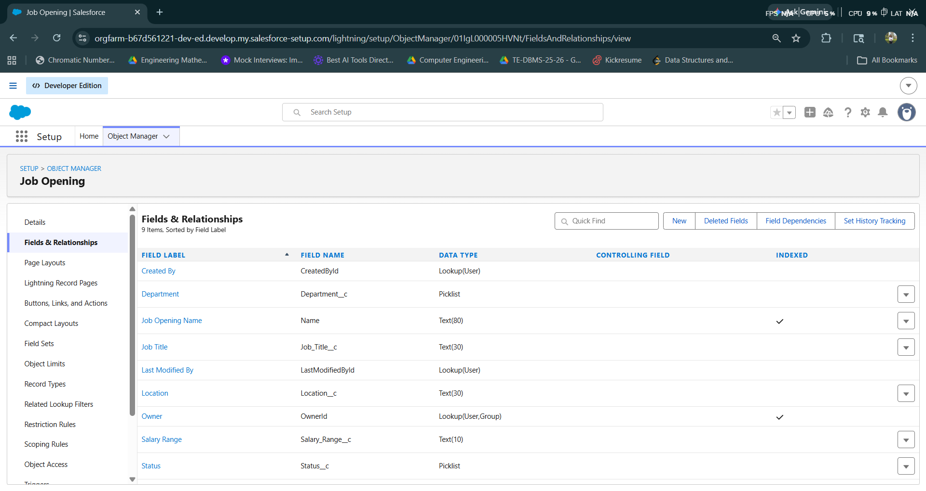
Step 3f : Create new Custom Tags for application
1. Candidate
2. Job Opening
3. Application
4. Interview
5. Recruiter
6. Offer
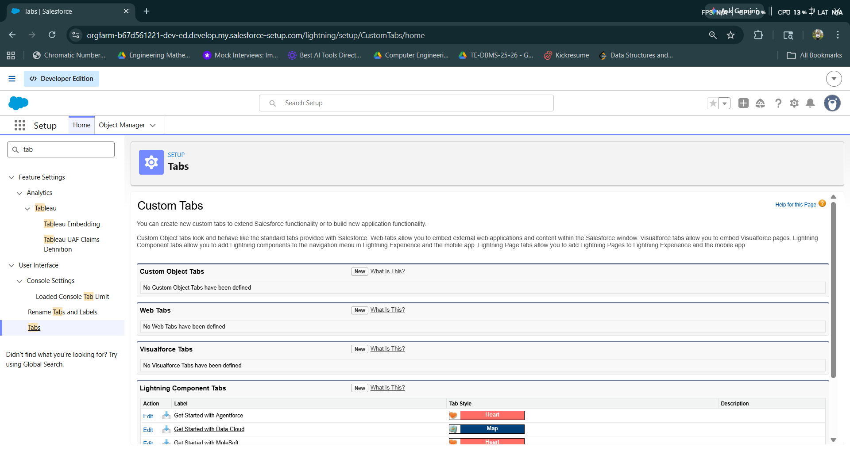
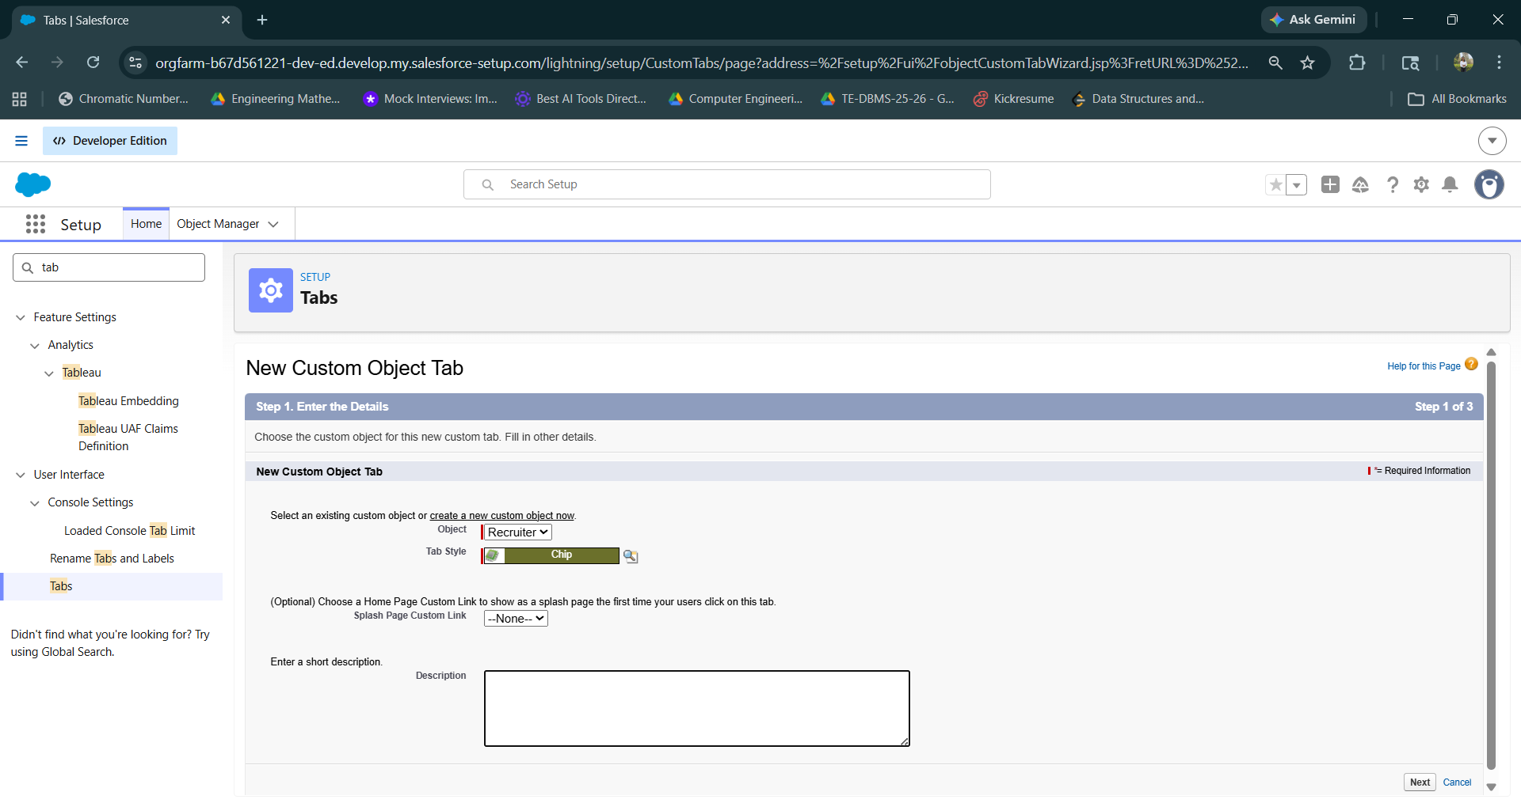
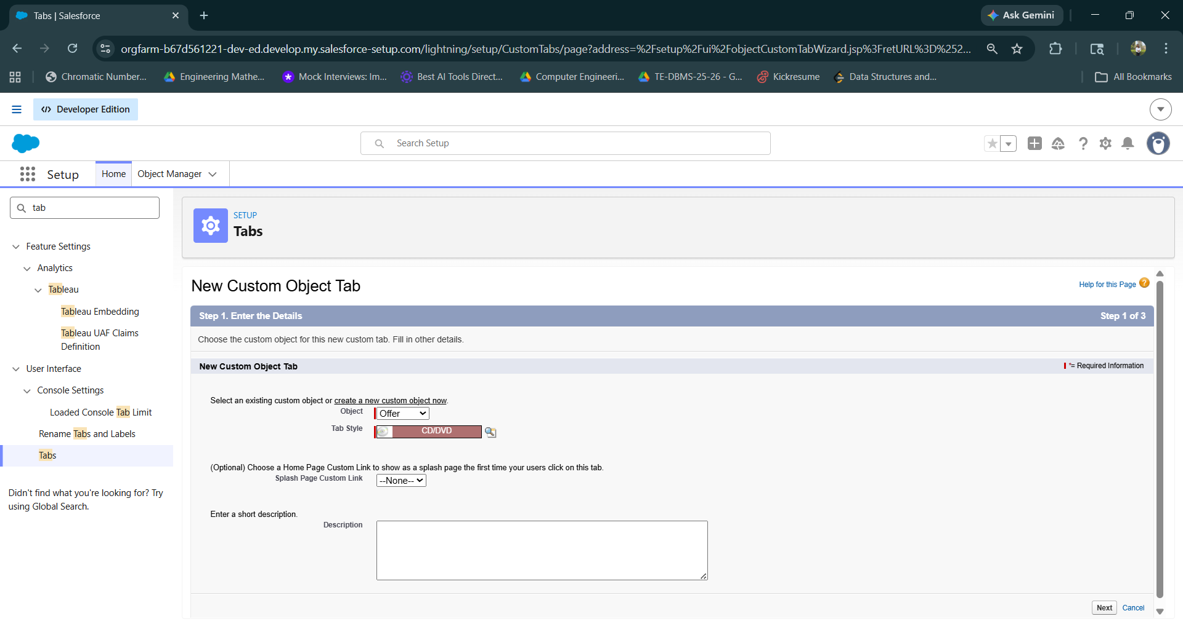
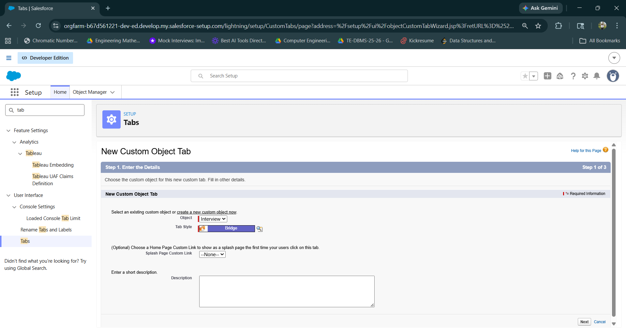

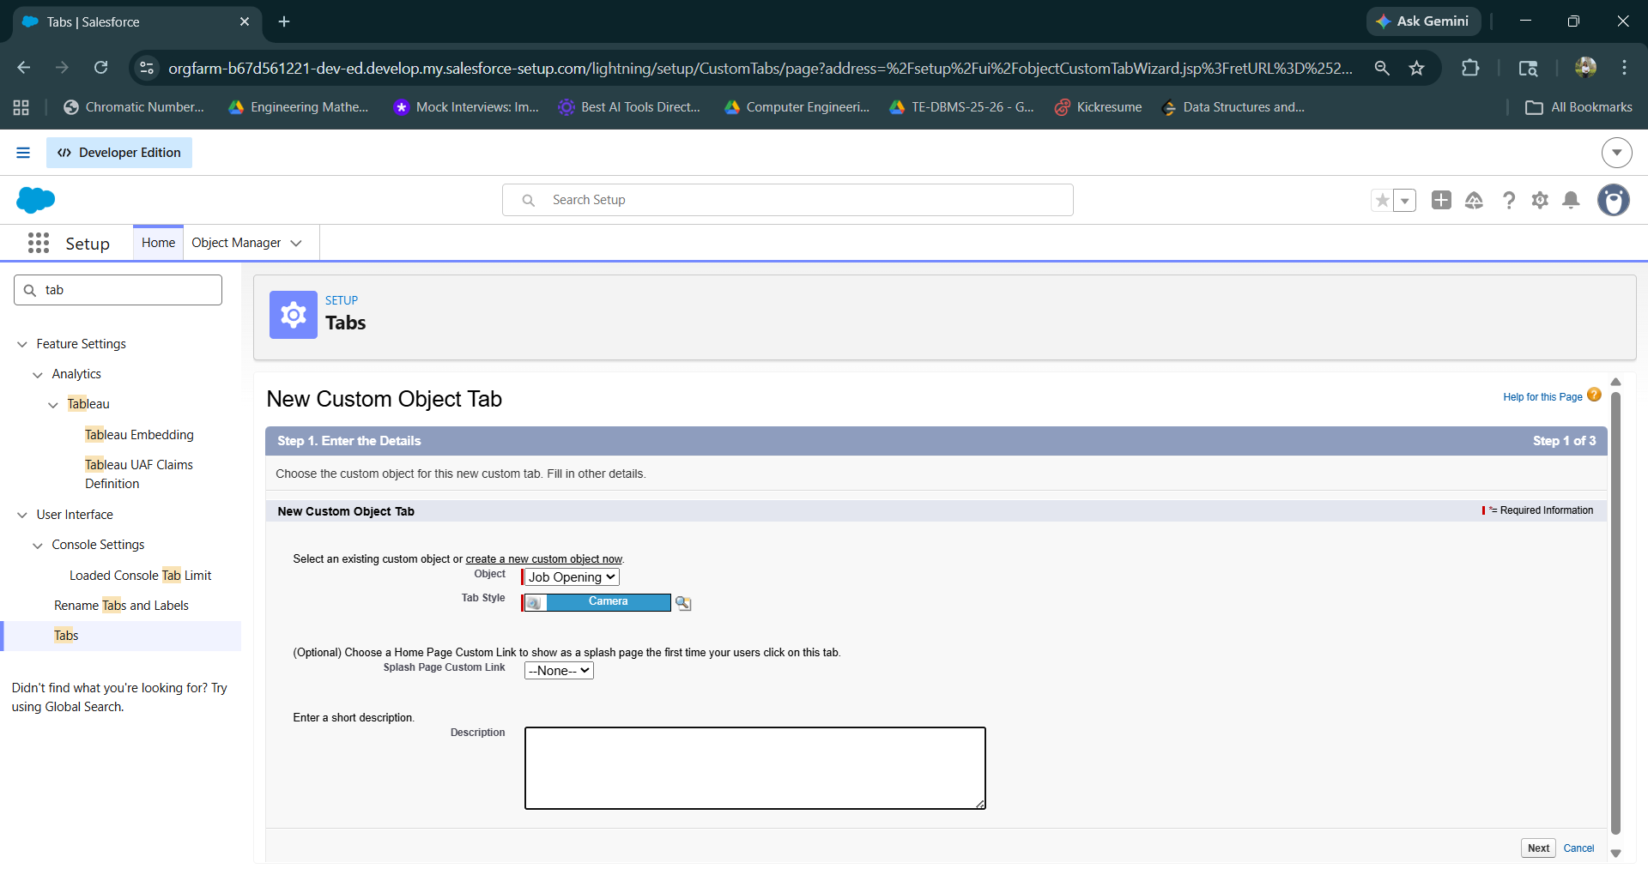
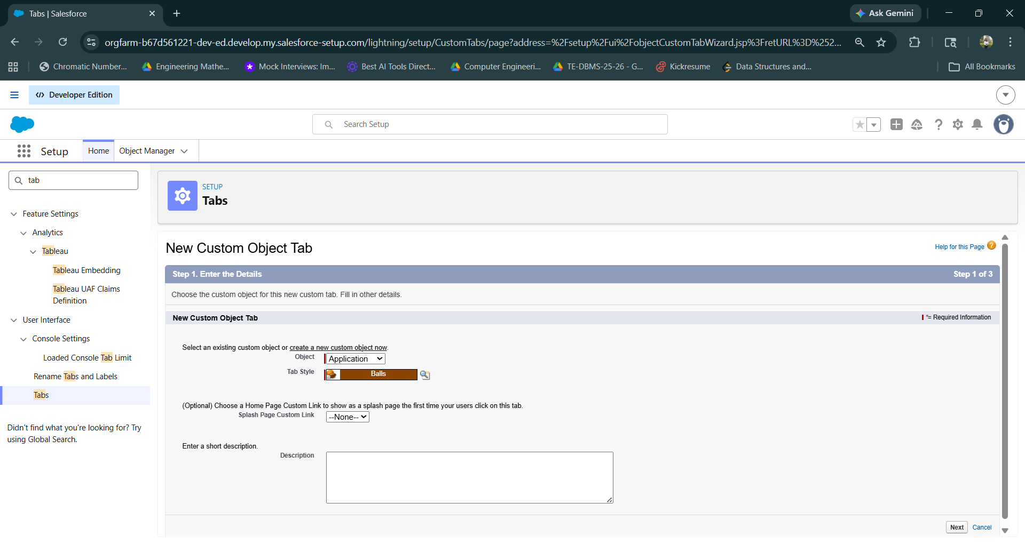
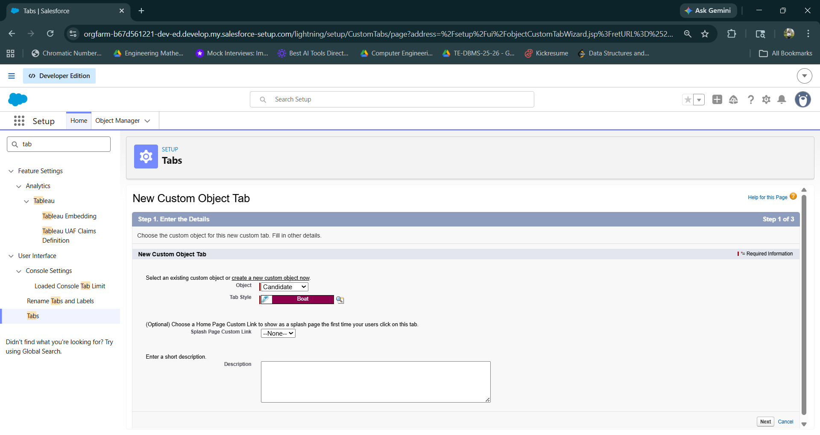
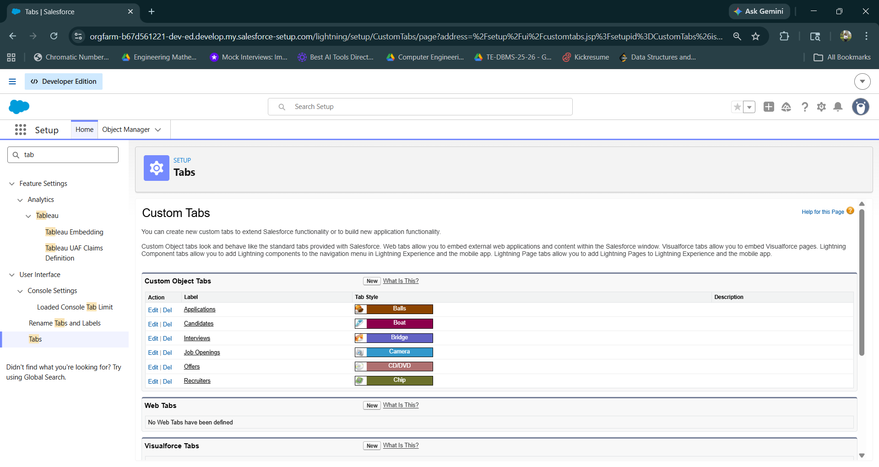
Step 3g : Navigate to App Manager and Click New Lightning App
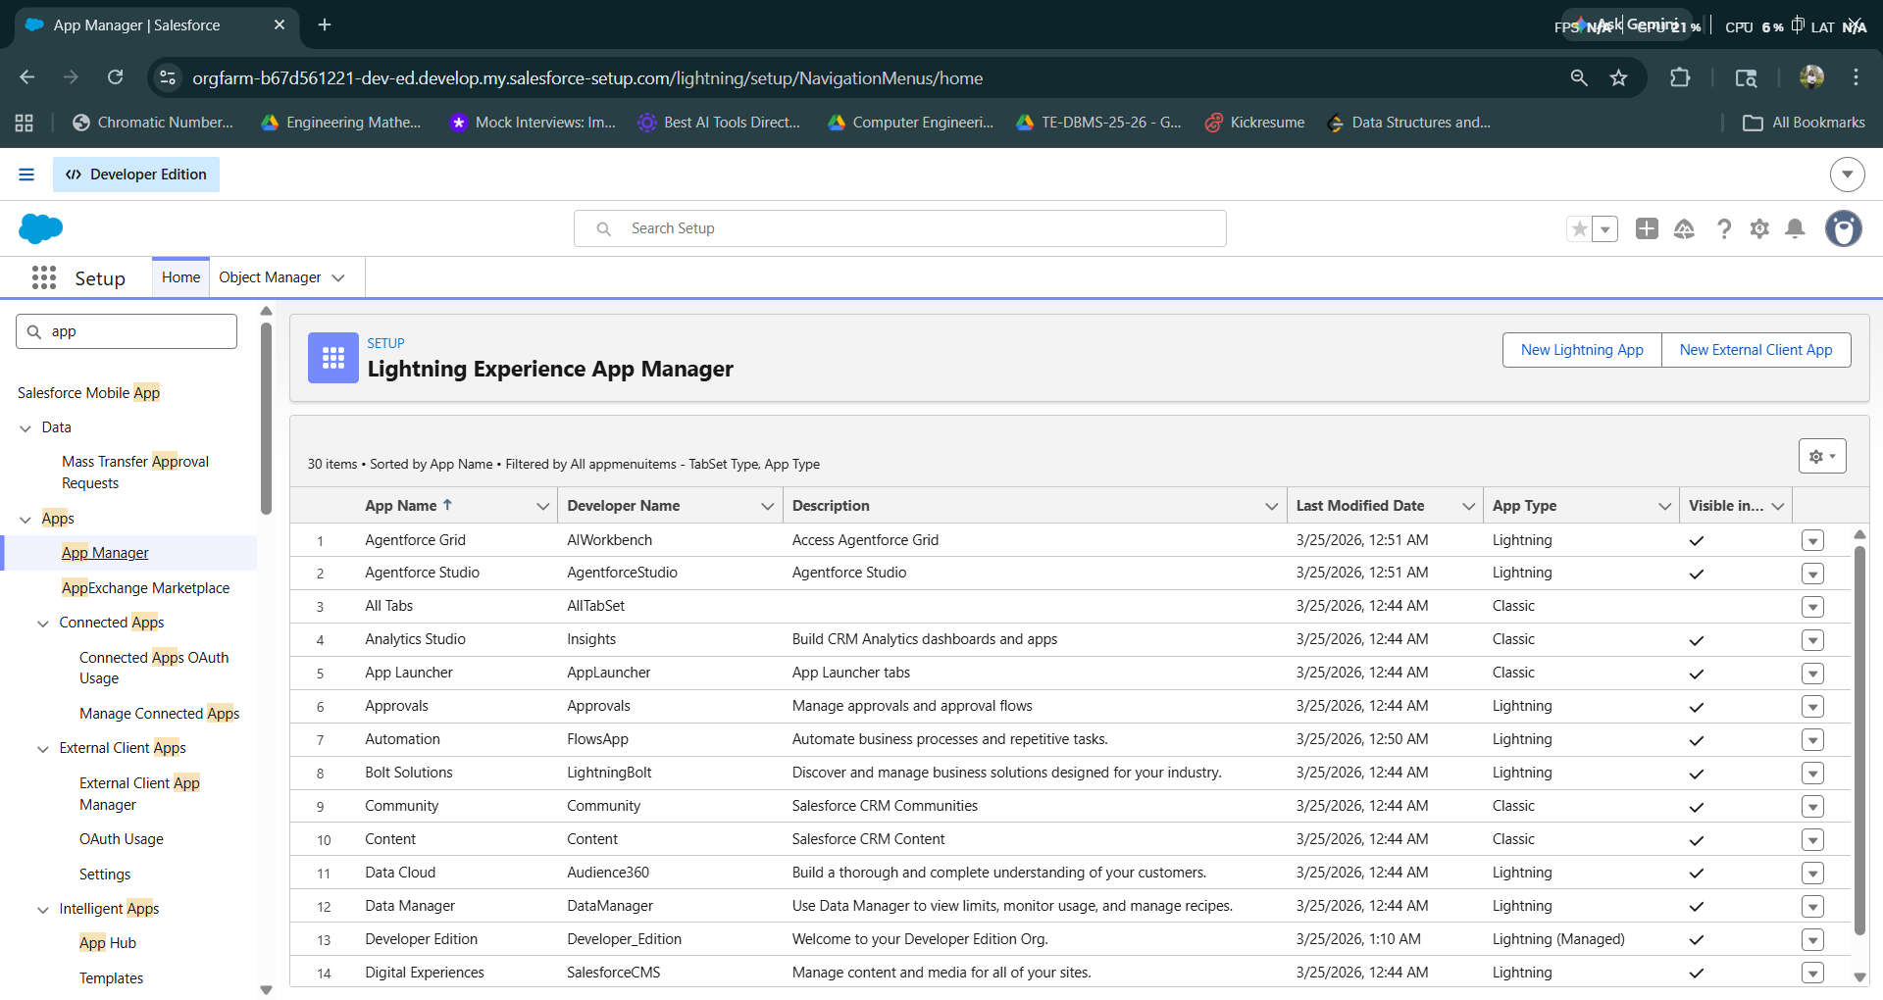
Step 3h : Find necessary fields and click next till Navigation Items
Enter App Name: Recruitment System
Click Next until Navigation Items.
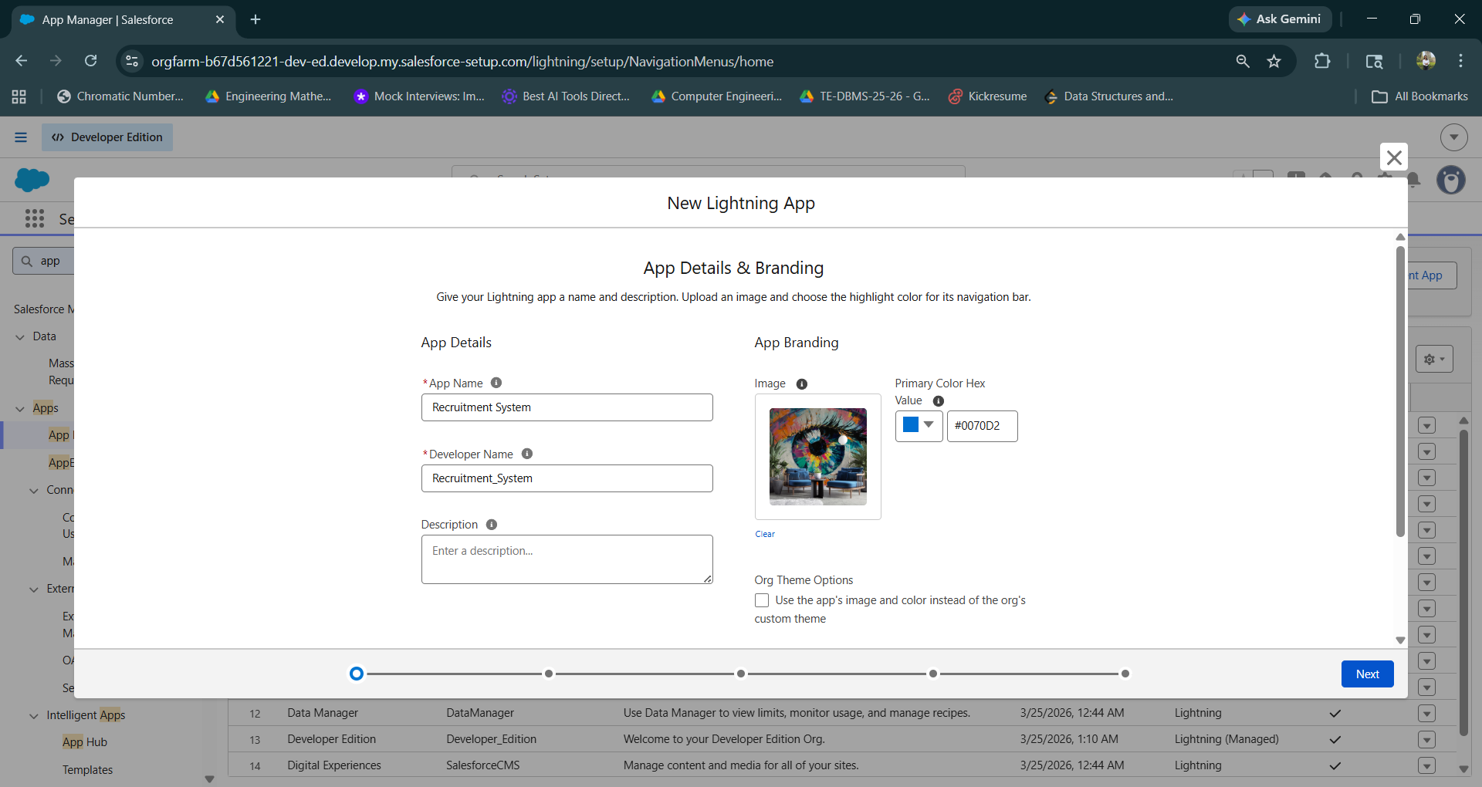
Step 3i : Add Navigation Items
Candidates, Job Openings, Applications, Interviews, Offers, Reports, Dashboards
Click Next

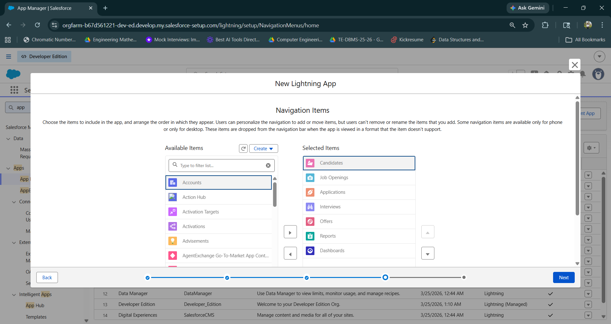
Step 3j : Add System Administrator and Standard User as User Profiles and Click Save & Finish.
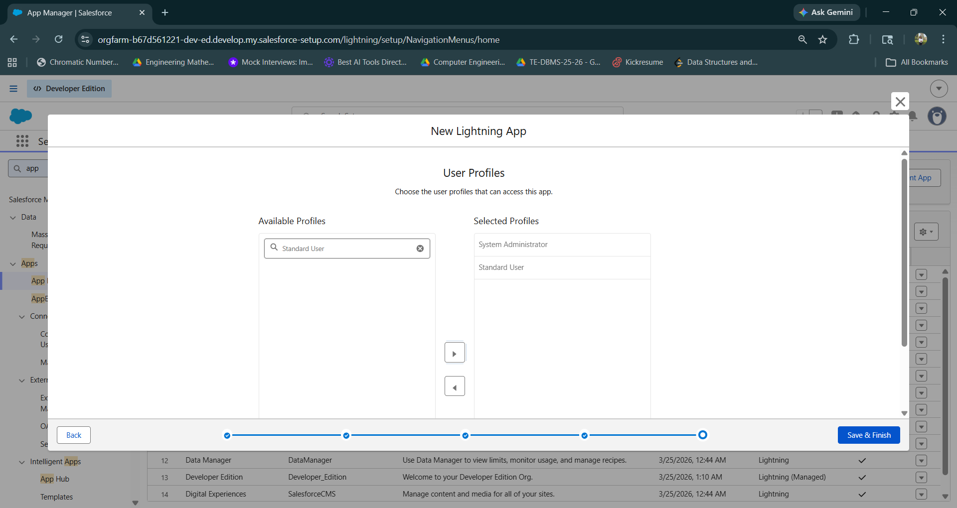
Step 3k : Now Navigate to your newly created Salesforce app
Here Recruitment System
Go to App Launcher → Recruitment System
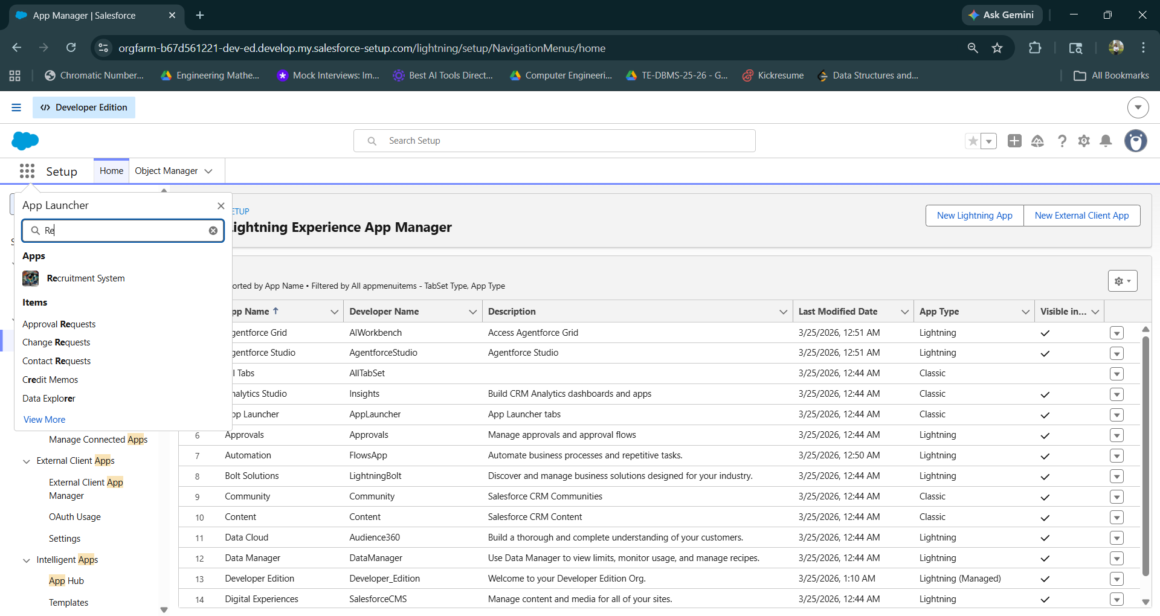
Step 3l : Now create new fields and enjoy managing the app
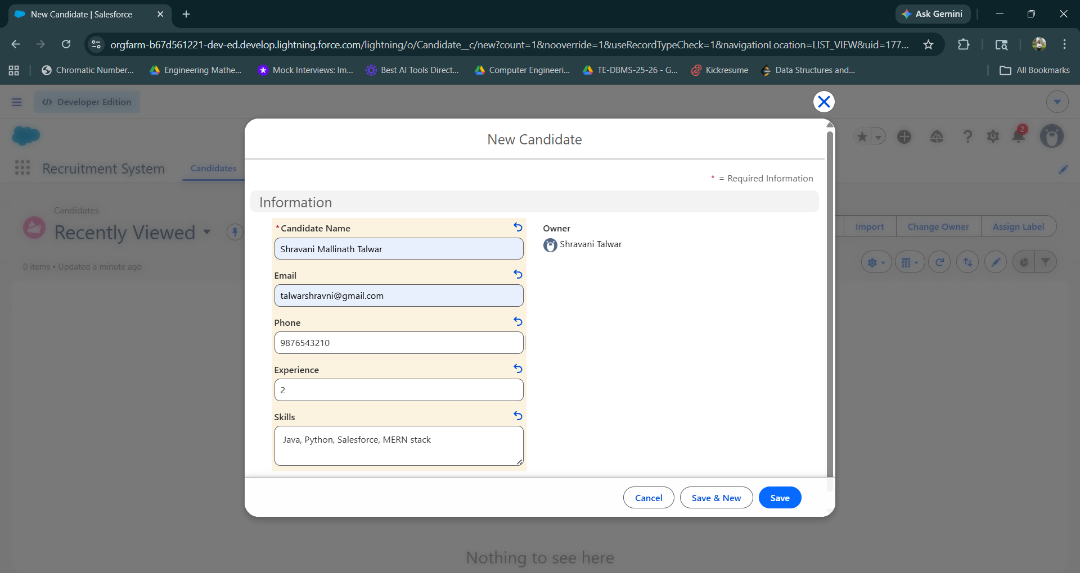
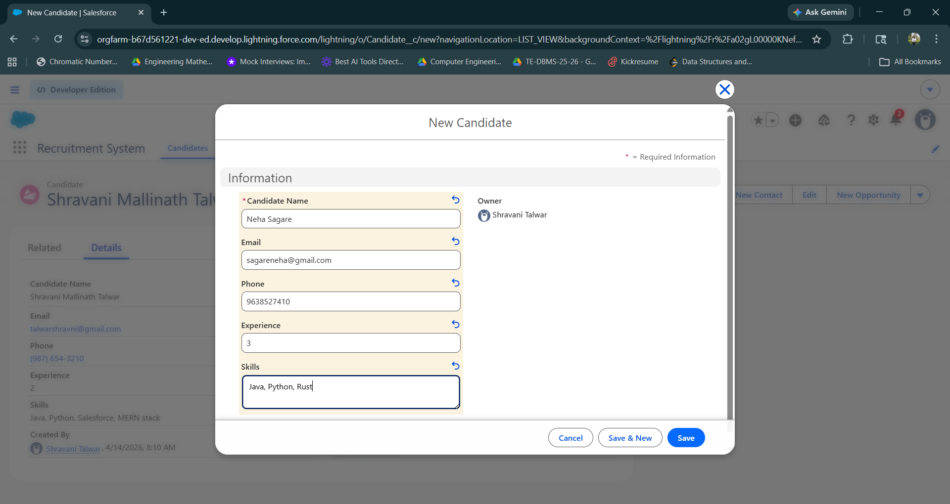
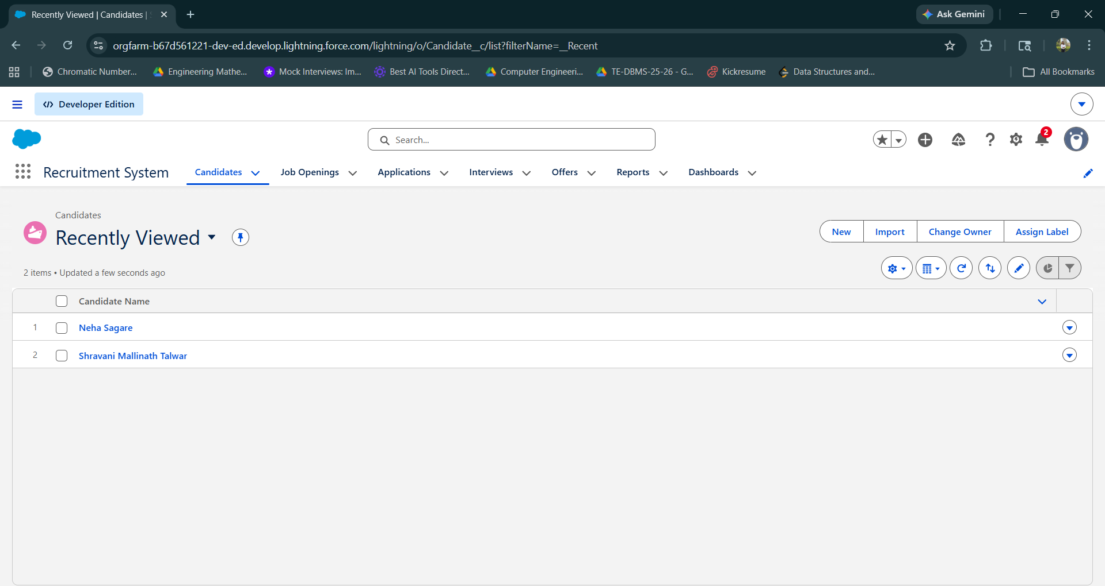
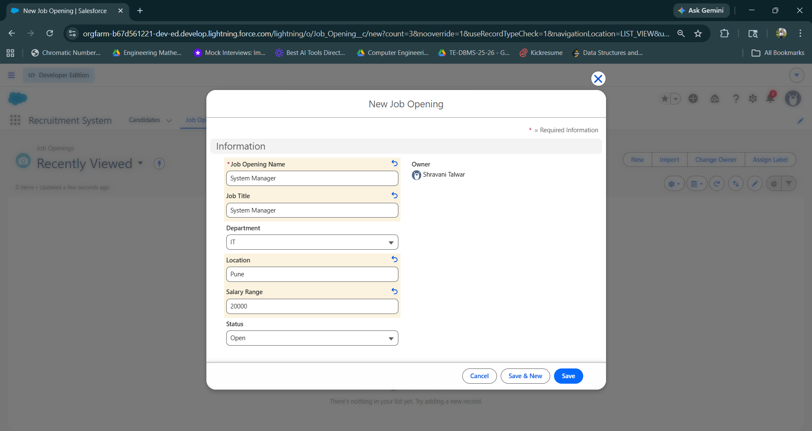
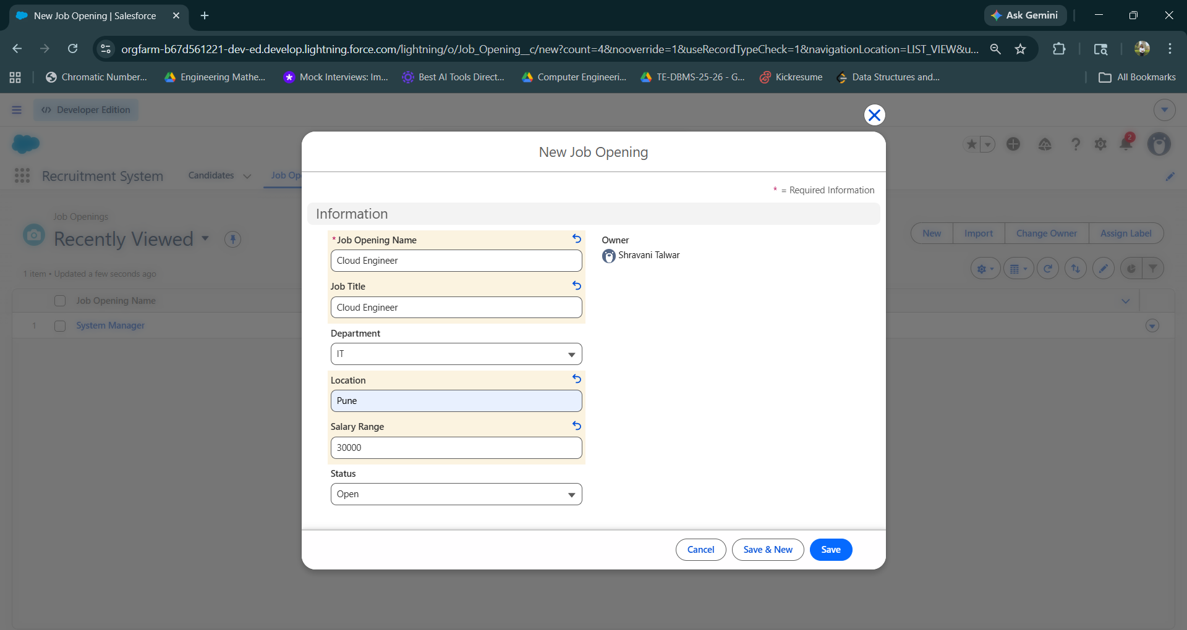
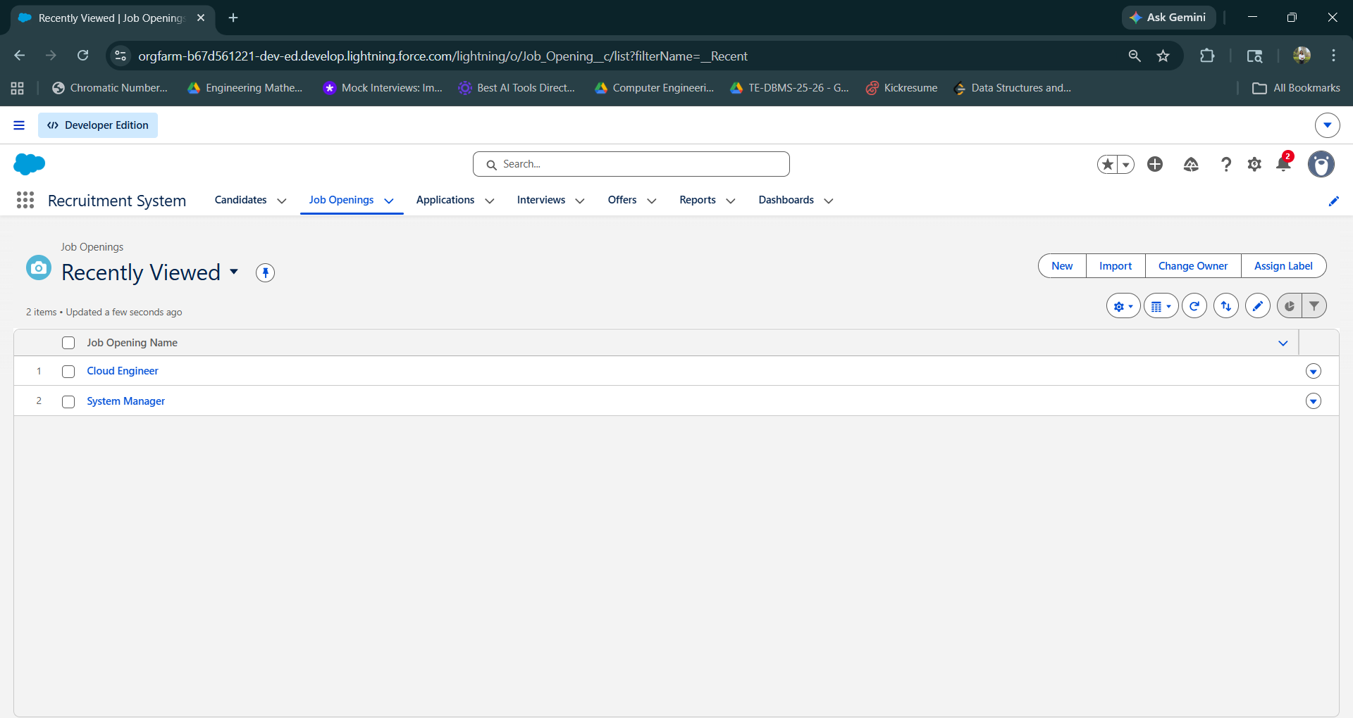
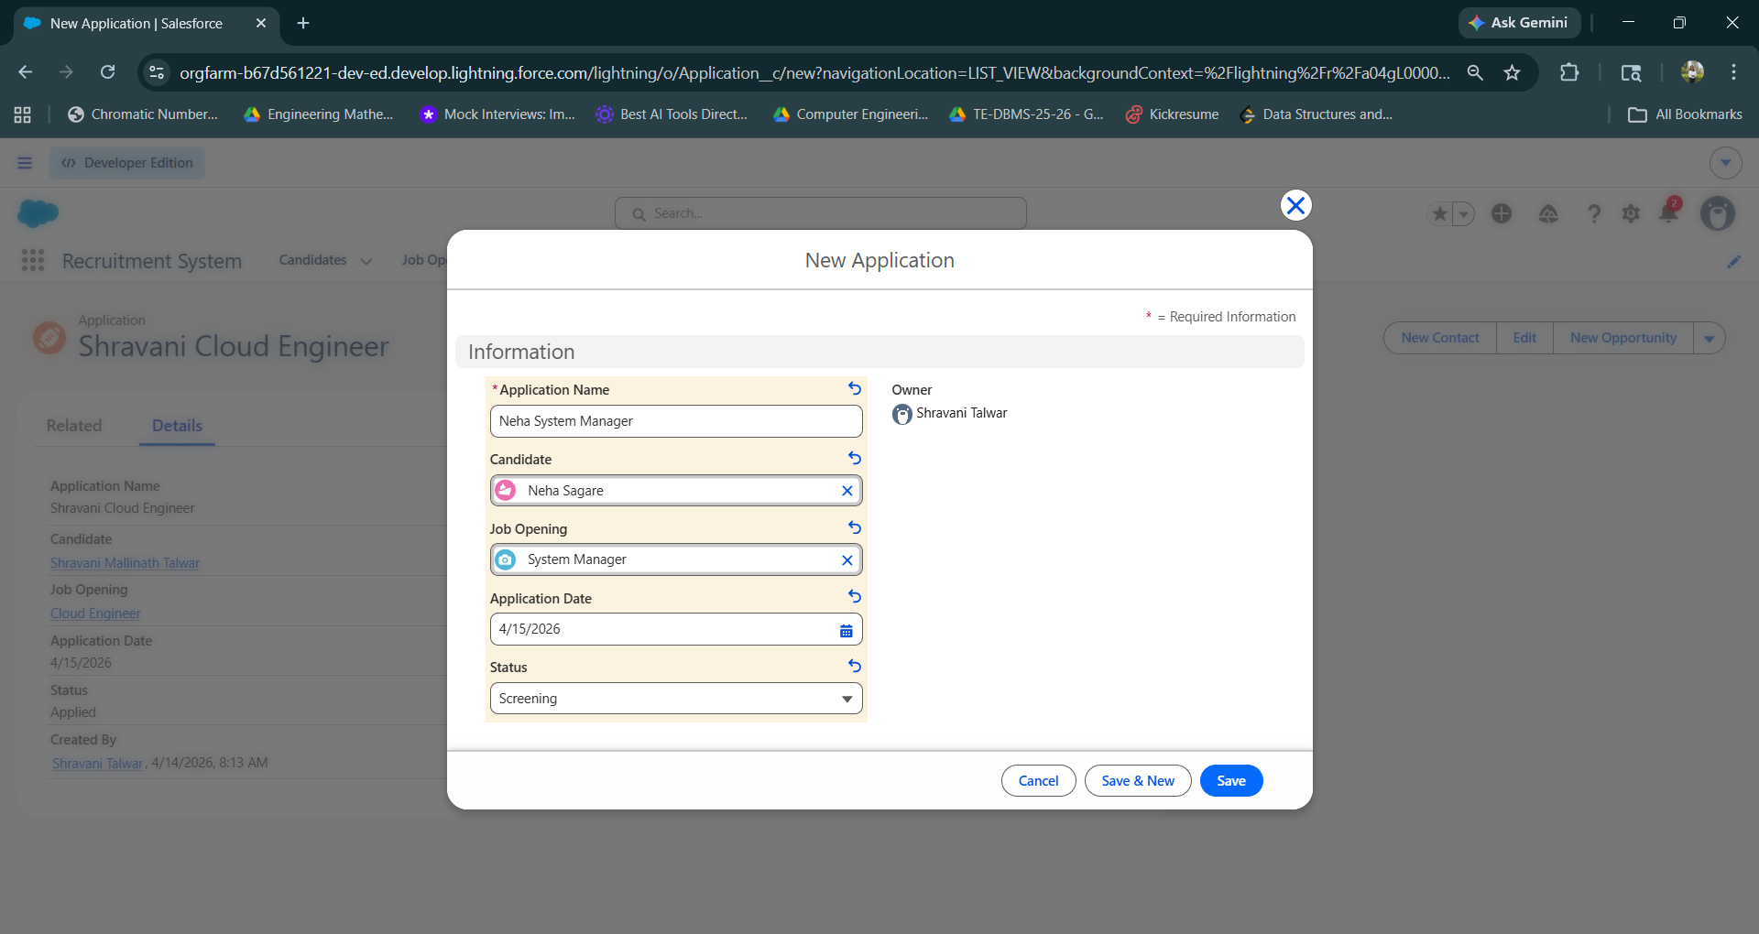
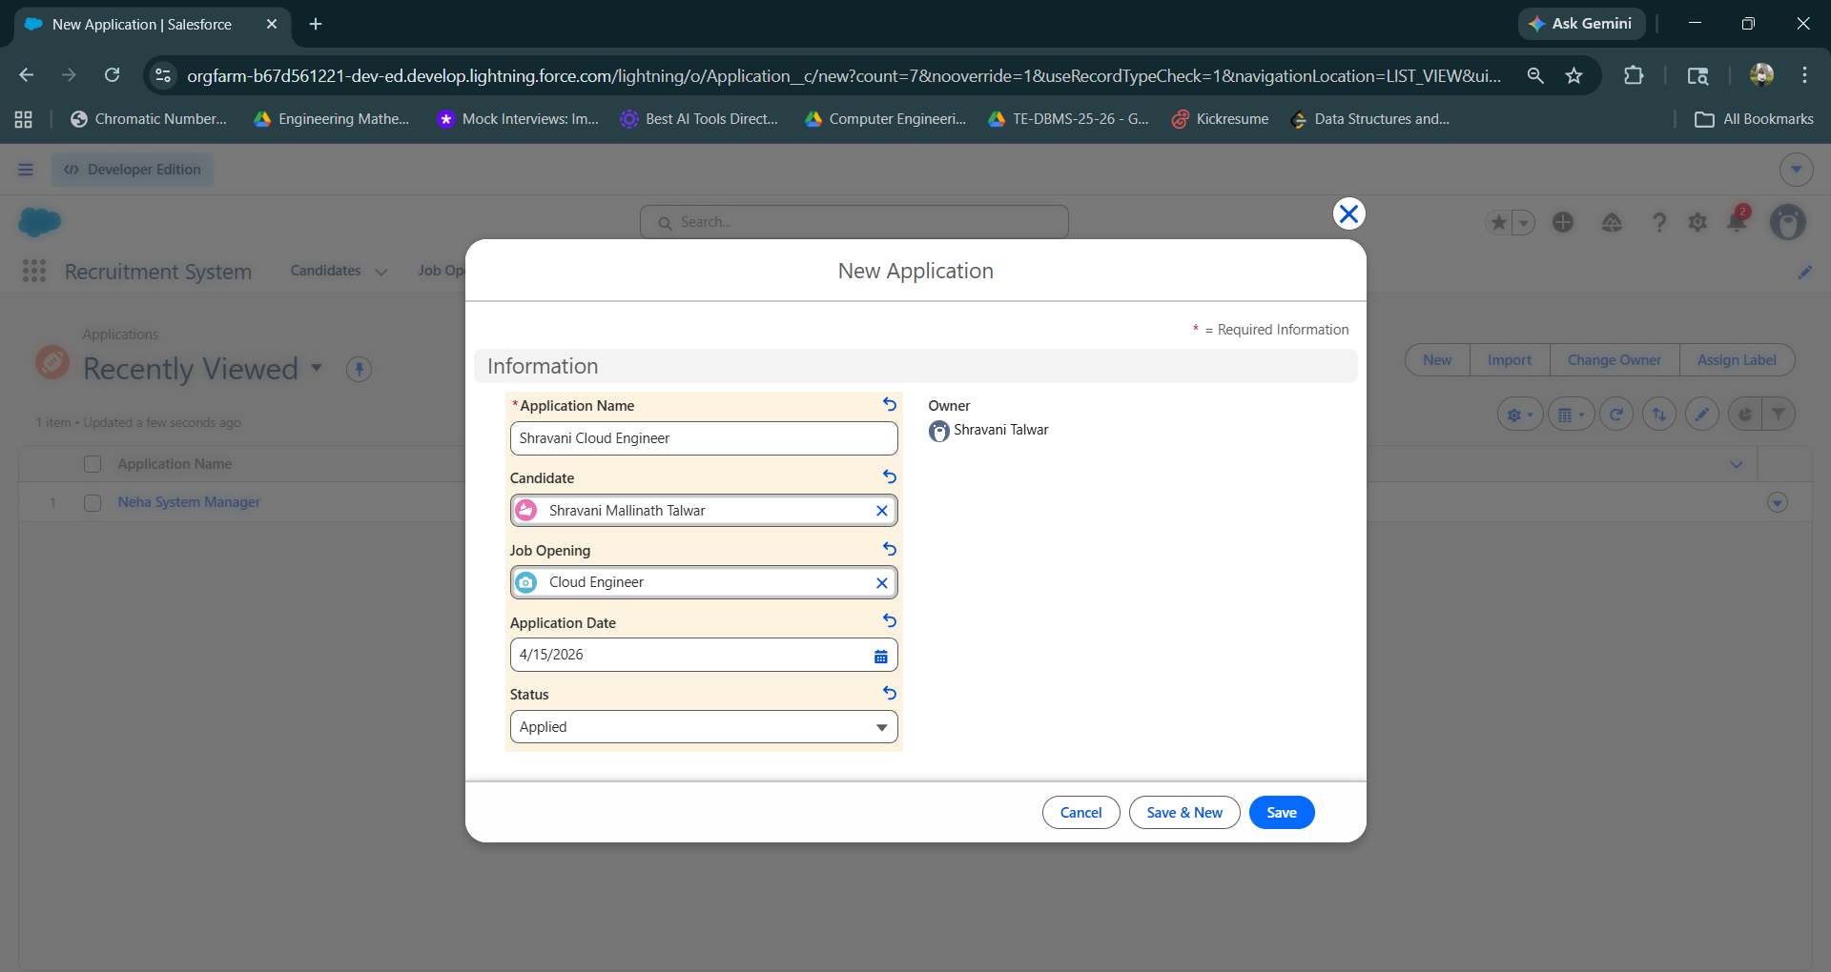
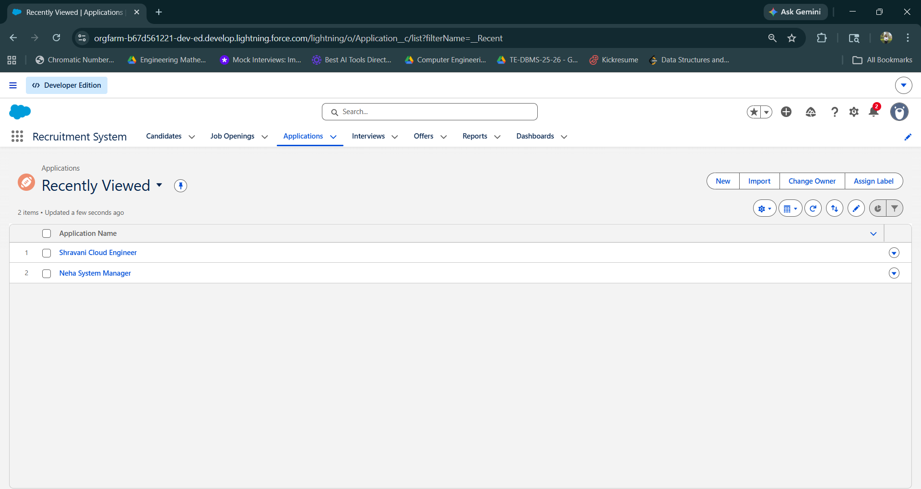
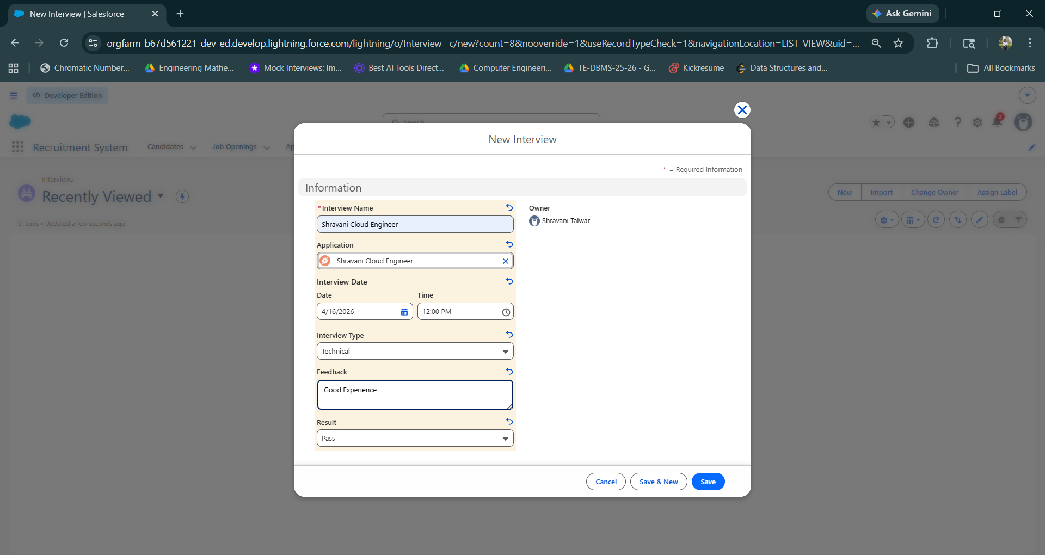
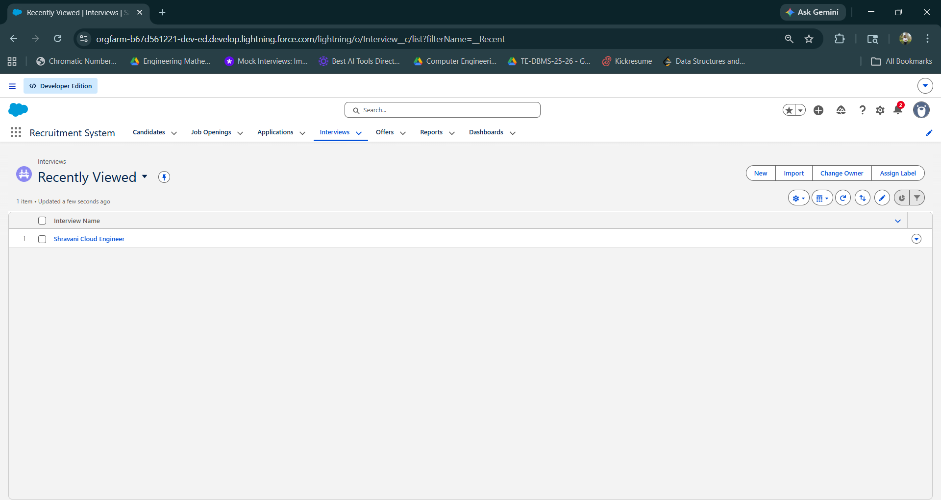
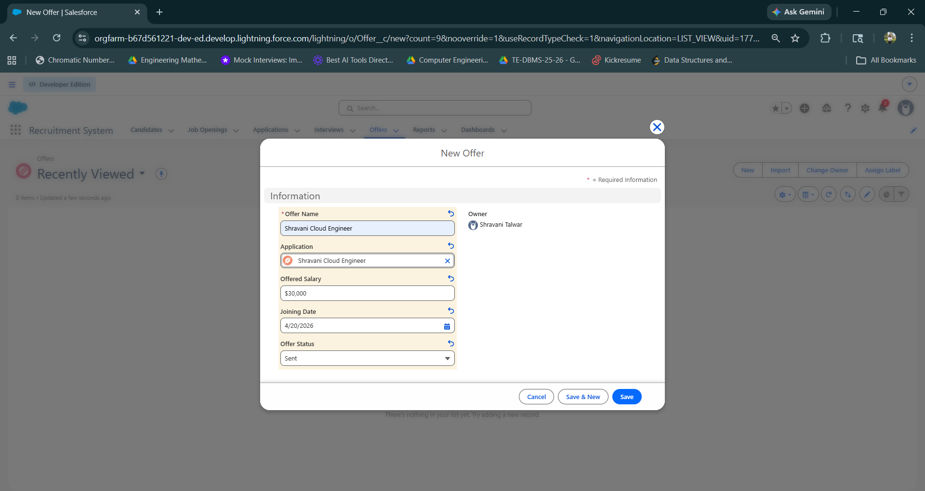
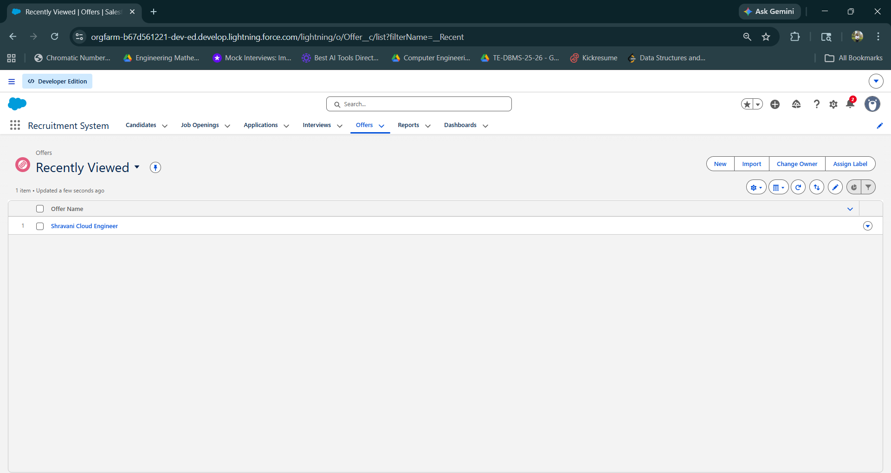

Conclusion : Successfully Designed and developed custom Application (Mini Project) using Salesforce Cloud.

